

Phase 3 Report
Project Title
PREDICTIVE ANALYTICS FOR URBAN WATER DEMAND
Problem Id: 06

Name: Nitin Singh
University Roll No: 2028786
Sec: Q

Name: Rohan Prasad Tiwari
University Roll No: 2028825
Sec: Q

Name: Ashutosh Singh
University Roll No: 2028675
Sec : Q

TABLE OF CONTENTS
- Problem Description ............................................................................................... 3
  - Dataset Description ........................................................................................... 3
  - Flow diagram ..................................................................................................... 4
- Modules for Project Implementation…………………..…………………………5
  - Modules Used
.............................................................................................................................
5
  - Platform Used
.............................................................................................................................
6
- Machine Learning model/ Searching Technique used ......................... 7
- Evaluation metrics used .............................................................................. 8
- Results and Visualizations .................................................................... 9-19
- Conclusion and Future Scope ..................................................................... 20
- References .................................................................................................... 21

1.Problem Description
Urban water demand is increasing due to rapid population growth, changing lifestyles, and environmental factors. Efficient prediction of water consumption is essential for proper planning and management of water resources. Traditional estimation methods are often inaccurate and fail to consider multiple influencing factors.
This project develops a machine learning-based system to predict daily water usage using features such as household size, seasonal index, garden area, temperature, rainfall, and other factors. The project applies multiple machine learning models including Linear Regression, KNN, SVM, and Decision Tree to improve prediction accuracy and classification performance.
Advanced techniques such as data preprocessing, feature scaling, and model evaluation using multiple metrics are applied to ensure reliable results. The system helps in better water resource management and supports data-driven decision-making for sustainable urban development.

  - Dataset Description

The dataset used in this project contains information related to urban water consumption. It includes multiple features that influence daily water usage and classification of water consumption.
Main features of the dataset include:
- Household_Size: Number of people in the household
- Income_Level: Income of the household
- Garden_Area: Area of garden affecting water usage
- Rainfall_mm: Rainfall amount
- Temperature_C: Environmental temperature
- Seasonal_Index: Seasonal variation factor
- Water_Price: Cost of water
- Appliance_Count: Number of water-using appliances
- Leakage_Factor: Water leakage level
- Daily_Liters_Used: Target variable (regression)
- Usage_Class: Classification target (high/low usage)
Additional engineered features:
- Per_Person_Usage
- Garden_Impact
- Water_Intensity
The dataset is preprocessed to handle noise, scaling, and feature transformation to improve model performance

1.2 Flow Diagram

2. Modules for Project Implementation

The project uses various Python libraries for data processing, visualization, and machine learning model development. Each module plays an important role in different stages of the project.
- Pandas (pd)
Pandas is used for data handling and preprocessing. It helps in reading the dataset, cleaning data, and performing operations on rows and columns. It makes it easy to analyze structured data.
- NumPy (np)
NumPy is used for numerical computations. It helps in performing mathematical operations such as arrays, mean calculation, and handling large datasets efficiently.
- Matplotlib (plt)
Matplotlib is used for basic data visualization. It helps in creating graphs like line plots, scatter plots, and bar charts to understand data patterns and model performance.
- Seaborn (sns)
Seaborn is an advanced visualization library built on Matplotlib. It is used to create attractive and informative graphs such as heatmaps, countplots, and distribution plots.
- Scikit-learn (sklearn)
Scikit-learn is the main library used for machine learning. It provides tools for data preprocessing, model training, and evaluation.
Modules used from Scikit-learn:
- train_test_split(): Splits data into training and testing sets
- StandardScaler(): Scales data for better model performance
- LinearRegression(): Used for regression model
- KNeighborsClassifier(): Used for KNN classification
- SVC(): Used for Support Vector Machine model
- DecisionTreeClassifier(): Used for decision tree model
- Metrics (accuracy_score, f1_score, recall_score, precision_score): Used to evaluate model performance
These modules together help in building a complete machine learning pipeline from data loading to model evaluation.

2.2 Platform Used:

  - Jupyter Notebook
Jupyter Notebook is used for writing and executing the code step-by-step. It allows easy visualization of outputs, graphs, and model results, making it suitable for data analysis and machine learning tasks.
  - Visual Studio Code (VS Code)
VS Code is used for writing, editing, and debugging the Python code. It provides a userfriendly interface with extensions that improve productivity and coding efficiency.
  - Python Environment
Python is used as the programming language due to its simplicity and availability of powerful libraries like Pandas, NumPy, Matplotlib, Seaborn, and Scikit-learn for data processing and machine learning.

- Machine Learning Model/ Searching Technique Used:

This project uses multiple machine learning models to improve prediction and classification performance. Each model has its own working principle and advantages.
- Linear Regression
Linear Regression is a supervised learning algorithm used for predicting continuous values. In this project, it is used to predict daily water usage. It finds a linear relationship between input features and the target variable.
Why used:
- Simple and easy to understand
- Works well for numerical prediction
- Provides good baseline performance
- K-Nearest Neighbors (KNN)
KNN is a classification algorithm that works based on similarity. It classifies a data point based on the majority class of its nearest neighbors.
Why used:
- Simple and effective
- No training phase required
- Works well for small to medium datasets
- Support Vector Machine (SVM)
SVM is a powerful classification algorithm that separates data using a decision boundary (hyperplane). It tries to maximize the margin between different classes.
Why used:
- Works well with complex data
- Effective in high-dimensional space
- Provides stable performance
- Decision Tree
Decision Tree is a model that makes decisions based on conditions. It splits data into branches based on feature values.
Why used:
- Easy to understand and interpret
- Handles both numerical and categorical data
- Provides feature importance
Overall, multiple models are used to compare performance and select the best model based on evaluation metrics like Accuracy, F1 Score, and Recall.

4. Evaluation metrics used :
- Accuracy
Accuracy measures how many predictions are correct out of total predictions. It gives an overall idea of model performance.
Accuracy = (TP + TN) / (TP + TN + FP + FN)
- Precision
Precision measures how many predicted positive values are actually correct. It is important when false positives need to be minimized.
Precision = TP / (TP + FP)
- Recall
Recall measures how many actual positive values are correctly predicted. It is important when missing positive cases is costly.
Recall = TP / (TP + FN)
- F1 Score
F1 Score is the harmonic mean of Precision and Recall. It provides a balance between both metrics and is useful when data is imbalanced.
F1 = 2 × (Precision × Recall) / (Precision + Recall)
- R² Score
R² Score is used for regression models. It shows how well the model explains the variation in the data. Values closer to 1 indicate better performance.
- Mean Squared Error (MSE)
MSE measures the average of squared differences between actual and predicted values. It gives higher weight to larger errors.
- Mean Absolute Error (MAE)
MAE measures the average absolute difference between actual and predicted values. It is easy to understand and less sensitive to large errors.
- ROC Curve and AUC
ROC Curve shows the performance of a classification model at different thresholds by plotting True Positive Rate vs False Positive Rate.
AUC (Area Under Curve) represents the overall performance of the model. Higher AUC value means better model performance.

- Results and Visualizations

- Heatmap
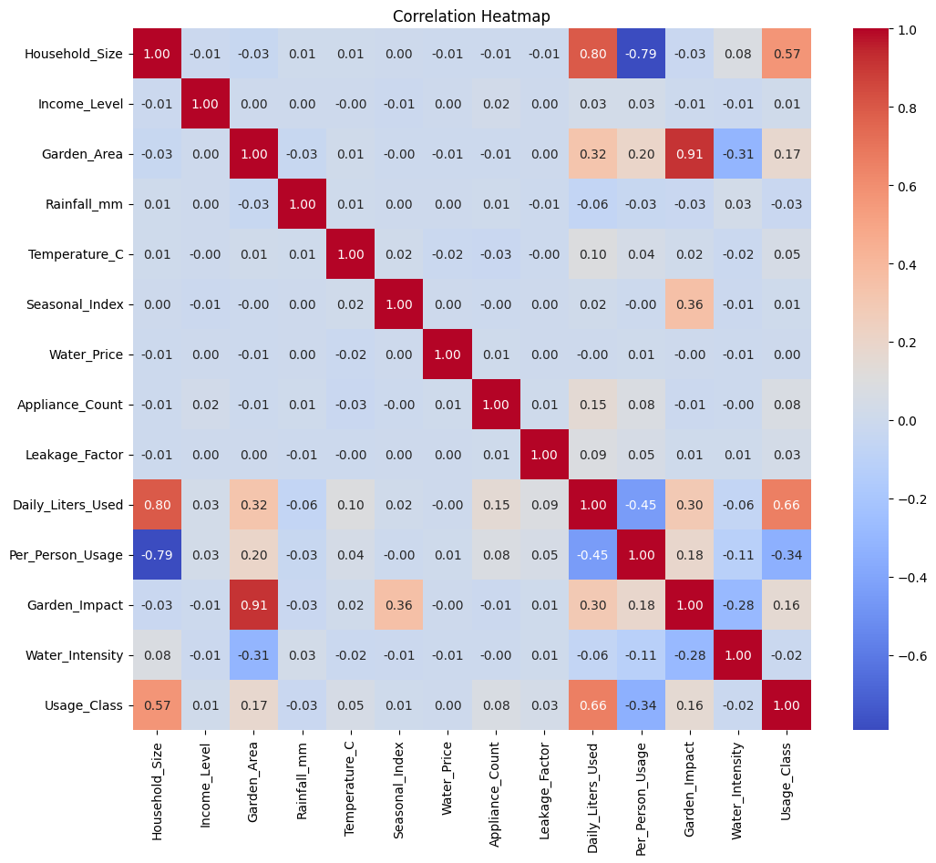

- Histogram (Data Distribution)
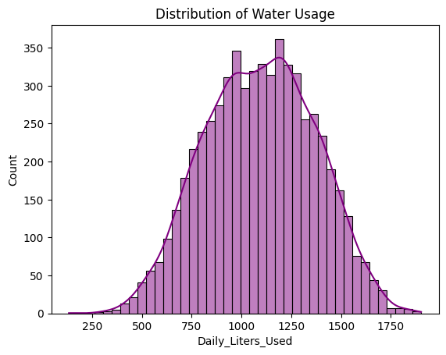

- Boxplot (Outlier Detection)
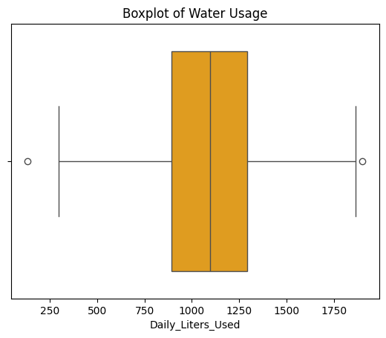
Linear Regression Analysis

* Scatter Plot (Actual vs Predicted)
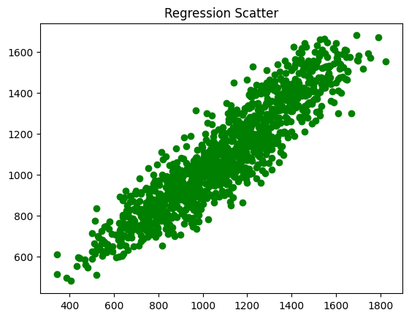
- Error Distribution Graph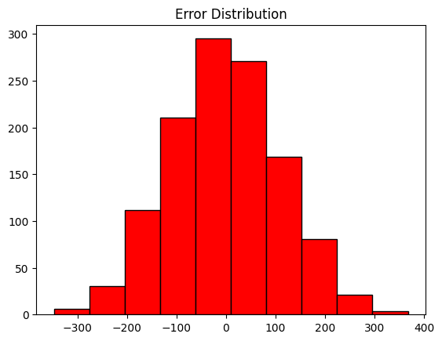
K-Nearest Neighbors (KNN)
- Confusion Matrix (KNN)
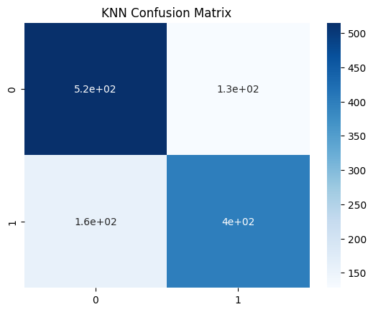
- Prediction vs Actual Graph

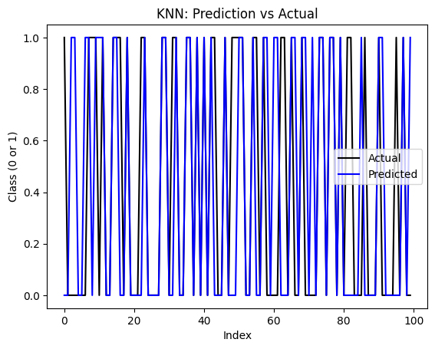
Support Vector Machine (SVM)
- Confusion Matrix (SVM)
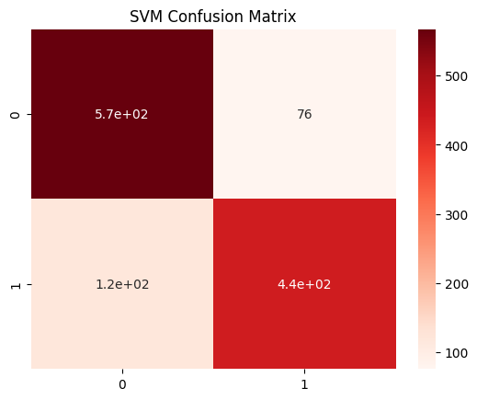
- Prediction vs Actual Graph
- 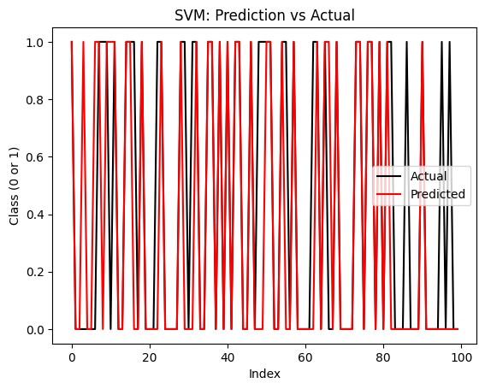
Decision Tree
- Confusion Matrix (Decision Tree)
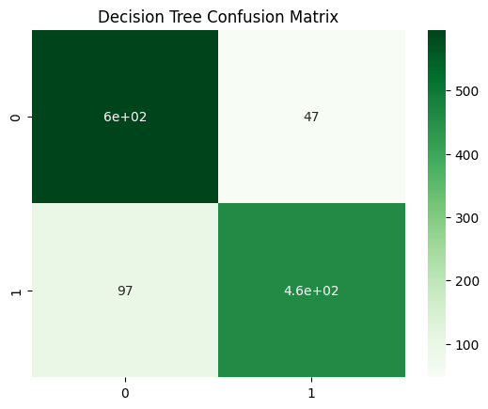
- Prediction vs Actual Graph
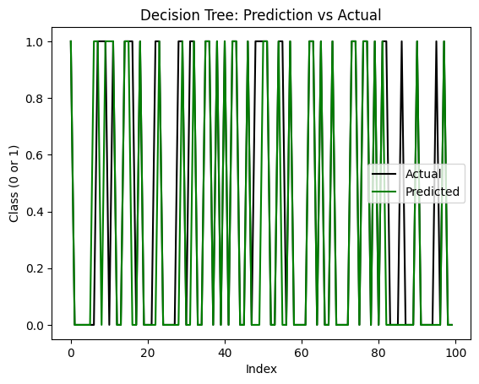

Model Comparison
- Accuracy Comparison Graph
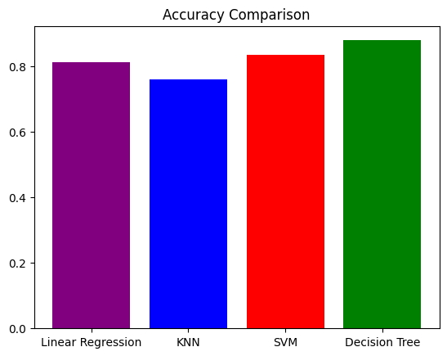
- ROC Curve (Model Comparison)

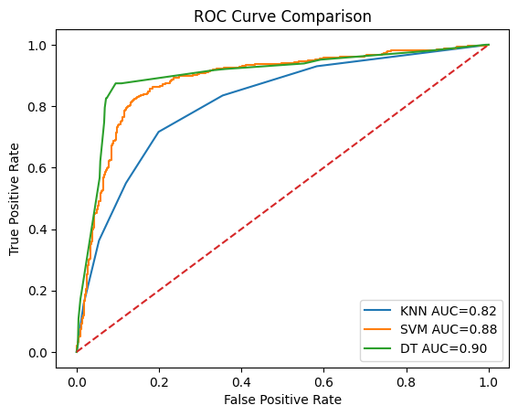

- Feature Importance Graph
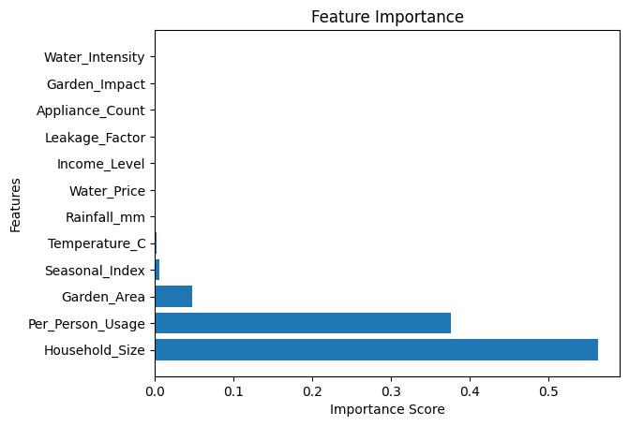

Results:

Model Accuracy F1 Recall Precision
0 LR 0.813333 0.798561 0.797127 0.800000
1 KNN 0.761667 0.736162 0.716338 0.757116
2 SVM 0.836667 0.816822 0.784560 0.851852
3 DT 0.880000 0.864662 0.825853 0.907298

Best Model based on F1 Score:
Model DT
Accuracy 0.88
F1 0.864662
Recall 0.825853
Precision 0.907298
Name: 3, dtype: object

* Models show balanced performance after tuning
* Decision Tree provides interpretable results
* SVM and KNN provide stable classification
* Linear Regression performs well for prediction Best Model:
*Selected based on highest F1 Score
* Provides balance between precision and recall

- Conclusion and Future Scope:

Conclusion:
This project successfully predicts and classifies urban water usage using multiple machine learning models. By applying preprocessing, scaling, and model tuning, the system achieves realistic and balanced performance. The use of multiple evaluation metrics ensures reliable model comparison.
Future Scope:
- Use advanced models like Random Forest and XGBoost
- Add real-time data integration
- Improve feature engineering
- Develop a user interface for monitoring water usage

7.References:
Books:
- Let Us Python – Yashavant Kanetkar
- Hands-On Machine Learning with Scikit-Learn – Aurélien Géron

Online Resources:
  - https://www.geeksforgeeks.org/
  - https://scikit-learn.org/

